Resources from the MHSIS Library for “ACTober” 2025
Content generated by Allison F. Sullivan, DOT, MSOT, OTR/L

ACT intervention resources:

- As Benjamin Triplett noted in his 6.16.25 post, James Hill is an OTP seasoned in the use of ACT. His website is The Morita School of Japanese Psychology, which has a collection of ACT-based interventions that can be used in groups or adapted for individual sessions. The pdf is one of the resources available on this website. From Processing Experiential Activities Using the DNA-V Model PDF from James Hill’s website The Morita School of Japanese Psychology:
OVERVIEW:
The DNA-V model was developed as an application of Contextual Behavioral Science for use with adolescents. It merges components of Acceptance and Commitment Therapy with Positive Psychology.
DNA represents metaphors symbolic of psychological processes / perspectives.
D = Discoverer – represents the process of exploring and testing the world (trial and error learning)
N = Noticer – represents our direct experience of our body, feelings, and sensory experience without analysis or judgment. It is a neutral observer
A = Advisor – represents our inner voice, our judgment. Its primary role is to keep us safe and secure and to figure out what might work based on our past learning experiences
V= Values – Awareness of what is important, which helps to guide more intentional actions in the world and responses to thoughts and feelings.
Because the DNA-V model is designed with adolescents in mind it is a developmental model which assumes that values are not necessarily well formed. The assumption is that clarification of values emerges from the interaction of the DNA functions. We test out our assumptions about what we value and notice what works and does not work, in the process we discover and refine our values. Though it is generally assumed that most adults have a better understanding of their values, it has been my experience that our values are information, transition, and development throughout our lives. Significant events like illness, loss, or disability often demands a reconsideration and prioritization of our values.
(Worksheet follows on next page)
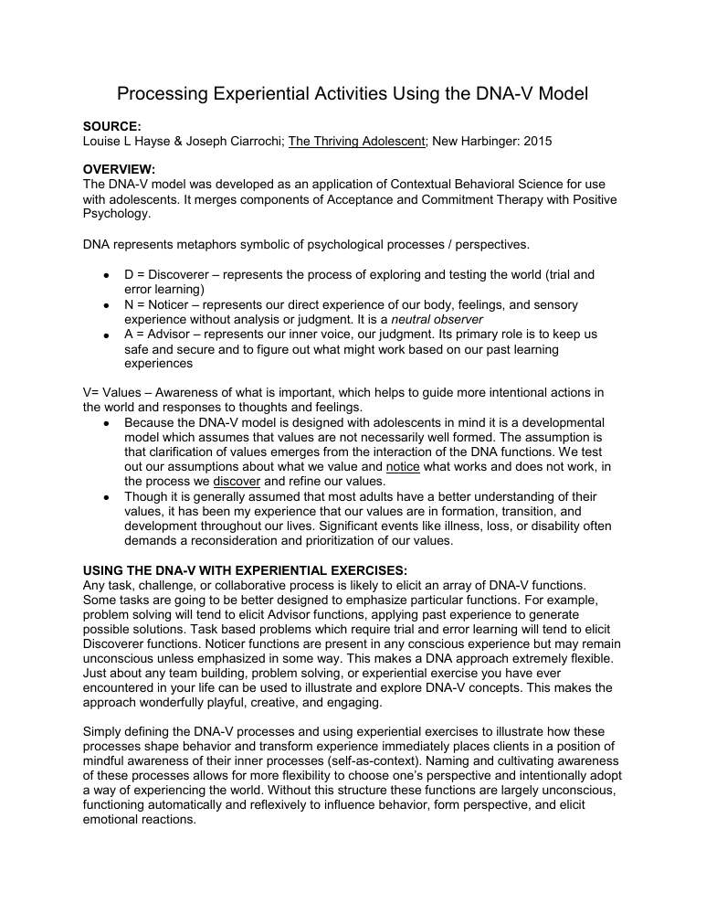

- UNWORKABILITY OF CONTROL EFFORTS (CREATIVE HOPELESSNESS) activities from James Hill’s Morita School of Japanese Psychology
As Benjamin Triplett noted in his 6.16.25 post, James Hill is an OTP seasoned in the use of ACT. His website is The Morita School of Japanese Psychology, which has a collection of ACT-based interventions that can be used in groups or adapted for individual sessions. The Unworkability of Control Efforts (Creative Hopelessness) is one category of ACT exercises from the website.

ACT in OT evidence:

- Reference: Haage, M., & Tjörnstrand, C. (2024). Experiences of occupational therapists within an ACT-based interdisciplinary pain management program. Scandinavian Journal of Occupational Therapy, 31(1), 1–11. https://doi-org.ezai.ez.cwmars.org:3243/10.1080/11038128.2024.2361635
ABSTRACT:
Background: Acceptance and Commitment Therapy (ACT)-based interdisciplinary pain rehabilitation programs have shown effective results. While occupational therapy within these programs has made a unique contribution to pain management because of its focus on occupation and use of group activities, little is known about occupational therapists’ own experiences of it.
Aim: The aim of this study was to describe the occupational therapists’ experiences of working in a manual-based interdisciplinary pain management program grounded in ACT.
Material and methods: Six occupational therapists at a pain rehabilitation clinic were interviewed. Data were analysed using Braun and Clark’s thematic analysis.
Results: The occupational therapists experienced that ACT and occupational therapy complement each other and that ACT facilitated comprehension of occupational therapy interventions. With ACT, the team gained a common language, which made teamwork and patient comprehension more efficient. A behavioural analysis (SORC) served as a link between occupational therapy and ACT.
Conclusions: Manual-based occupational therapy activity group interventions with elements of ACT were felt to enhance the patient’s understanding of their rehabilitation and supported teamwork.
Significance: This study provides further support for use of ACT in occupational therapy within interdisciplinary pain management programs. Occupational therapistsˈ use of SORC is an area of development.

- Reference: Hara R, Hiraga Y, Hirakawa Y (September 24, 2023) Occupational Therapy Practice With Cognitive Behavioral Therapy for Early Postoperative Pain: A Case Report. Cureus 15(9): e45882. DOI 10.7759/cureus.45882
Abstract: Structuring psychological interventions using cognitive behavioral therapy in the early postoperative period is crucial to mitigate the risk of chronic pain. In this study, specific practices were presented through the case of a woman in her 60s who experienced psychological factors, such as catastrophic thinking and anxiety, due to pain after high tibial osteotomy. The aim was to evaluate the structure of cognitive behavioral therapy and its application in the early postoperative period. Cognitive behavioral therapy was initiated postoperatively, incorporating three phases: cognitive restructuring, coping skills and active pacing, and occupational therapy. As a result of occupational therapy using cognitive behavioral therapy, the patient’s pain and anxiety are reduced while achieving the goals. This case study suggests that cognitive behavioral therapy may promote goal attainment in cases where postoperative pain exacerbates psychological factors, such as catastrophic thinking and anxiety, ultimately leading to functional impairments. Implementation of cognitive behavioral therapy in Japan is lacking, necessitating urgent development. This case report serves as a foundational step in structuring cognitive behavioral therapy during the early postoperative period in Japan

- Reference: Carey, M., Kerr-Gaffney, J., Strawbridge, R., Hieronymus, F., McCutcheon, R., Young, A., & Jauhar, S. (2025). Are cognitive behavioural therapy, cognitive therapy, and behavioural activation for depression effective in primary care? A systematic review and meta-analysis, Journal of Affective Disorders, (382), 215-226, ISSN 0165-0327, https://doi.org/10.1016/j.jad.2025.04.070
Abstract: Cognitive behavioural therapy (CBT) is a recommended first-line treatment for depression. Evidence mainly derives from studies in secondary care, though most treatment occurs in primary care. This review examined efficacy of CBT, cognitive therapy (CT), or behavioural activation (BA) for depression within primary care. Databases were searched for trials up to 23rd July 2024. Risk of bias was assessed using the Cochrane risk-of-bias tool, version 2.0.44 studies were included. CBT, CT, and BA significantly reduced depression symptoms compared to inactive controls (k = 40, g = 0.44, p < .001), but not active comparators (other therapies, medication or exercise) (k = 9, g = −0.06, p = .24). Heterogeneity was significant in studies comparing CBT, CT, or BA to inactive controls, but not in studies using active comparators. Most studies were rated at high risk of bias (36 studies, 81.8 %), predominantly due to use of patient-rated outcome measures in non-blinded studies, lack of ITT analyses, and lack of pre-registering protocols, all of which may result in inflated effect sizes. Although CBT, CT, or BA appears effective for depression in primary care against usual care or waiting list controls, when compared to active comparators no significant difference is seen, likely a result of variability in the quality of the included studies. Large studies of improved quality (including use of blinded observer-rated outcome measures and ITT analyses) may be required to justify guideline recommendations for CBT over other interventions for depression specifically in primary care.

- Reference: Zhu JY, Yiming A, Zeng JQ. 2025. Depression in postmenopausal women with osteoporosis: Integrating psychological nursing into holistic care. World Journal of Psychiatry 15(9): 110536
Abstract: Depression is highly prevalent among postmenopausal women with osteoporosis, driven by the combined effects of hormonal changes, reduced bone density, and psychosocial stress. A recent study by Cui and Su reported that 73.3% of affected women exhibited depressive symptoms, with low bone mineral density, chronic comorbities, and reduced serotonin (5-hydroxytryptamine) levels as key risk factors. Notably, nurse-led psychological interventions improved both mood and quality of life. This editorial underscore the need to integrate mental health support into standard osteoporosis care. Simple, scalable strategies such as routine screening and nurse-delivered emotional support may help bridge the gap between physical and psychological health. These approaches are especially relevant for aging populations across diverse healthcare settings. A dual focus on bone and emotional well-being is essential to improving outcomes in this vulnerable group.
URL: https://www.wjgnet.com/2220-3206/full/v15/i9/110536.htm
DOI: https://dx.doi.org/10.5498/wjp.v15.i9.110536

- Reference: Pisegna, J., Anderson, S., & Krok-Schoen, J. L. (2022). Occupational therapy interventions to address depressive and anxiety symptoms in thephysical disability inpatient rehabilitation setting: A systematic review. American Journal of Occupational Therapy, 76, 7601180110. https://doi.org/10.5014/ajot.2022.049068
ABSTRACT:
Importance: Depressive and anxiety symptoms across physical disability inpatient rehabilitation (IPR) patient groups are well documented and negatively affect functional recovery. The strategies within the occupational therapy scope of practice to address these symptoms in IPR are unclear.
Objective: To determine what interventions within the occupational therapy scope of practice have been used to address depressive and anxiety symptoms in IPR and to determine intervention efficacy.
Data Sources: Nine databases for all publication years were searched (PubMed, Scopus, Embase, Web of Science, PsycINFO, Cochrane Library, AgeLine, OTseeker, and CINAHL).
Study Selection and Data Collection: Preferred Reporting Items for Systematic Reviews and Meta-Analyses (PRISMA) guidelines were used for abstracting data and assessing quality. Included articles were peer reviewed, based in the United States, in English, controlled clinical trials or randomized controlled trials, in the IPR setting, and within the occupational therapy scope of practice. Two reviewers independently screened articles, with disagreements resolved by consensus.
Findings: Five of 8,082 articles met inclusion criteria. Diagnoses included stroke (n 5 1), traumatic brain injury (n 51), spinal cord injury (n 51), and musculoskeletal conditions (n 5 2). Results are discussed among four categories:study design and outcome variables, intervention type, intervention intensity, and intervention efficacy.
Conclusions and Relevance: Limited, moderate-quality evidence exists within the occupational therapy scope of practice for addressing depressive and anxiety symptoms in the physical disability IPR setting. Interventions primarily included cognitive and behavioral strategies. Further research among diverse patient populations is needed to support occupational therapy practitioners in facilitating client participation and functioning.

AJOT’s Authors and Issues YouTube with corresponding AJOT articles:

- AJOT Authors and Issues Session 4 with Aaron Eakman: Sleep and Veterans: https://youtu.be/tlPEi8pu-bg?si=PNOQkM_nLSruLJC4
- Corresponding Article: Follow-Up Analyses From a Wait-List Controlled Trial of Occupational Therapist–Delivered Cognitive– Behavioral Therapy for Insomnia Among Veterans With Chronic Insomnia
Reference: Eakman, A. M., Schmid, A. A., Rolle, N. R., Kinney, A. R., & Henry, K. L. (2022). Follow-up analyses from a wait-list controlled trial of occupational therapist–delivered cognitive–behavioral therapy for insomnia among veterans with chronic insomnia. American Journal of Occupational Therapy, 76, 7602205110. https://doi.org/10.5014/ajot.2022.045682

ABSTRACT:
Importance: Veterans often experience chronic insomnia, and professionals capable of delivering effective interventions to address this problem are lacking.
Objective: To evaluate the efficacy of the Restoring Effective Sleep Tranquility (REST) program, an occupational therapist–led cognitive–behavioral therapy for insomnia (CBT–I) intervention to treat sleep problems among post-9/11 veterans.
Design: Wait-list controlled trial with 3-mo follow-up.
Setting: Community-based veteran support program in a Mountain West university.
Participants: Fifteen post-9/11 veterans with sleep disturbances who were assigned to either the REST intervention or a wait-list control group.
Outcomes and Measures: Sleep-related, health-related, and participation-related patient-reported outcomes(PROs) and daily sleep diary variables.
Results: Wait-list controlled trial benefits included improved sleep-related (e.g., sleep disturbance), health-related (e.g., depression), and participation-related (e.g., meaningful activity) PROs. Findings were confirmed after participants in both the intervention and the control groups (n 5 13) received the REST intervention, including improved daily sleep diary outcomes (e.g., sleep efficiency). All gains were maintained at 3 mo.
Conclusions and Relevance: Occupational therapy practitioners with advanced training in CBT–I have the potential to safely deliver an effective CBT–I intervention to veterans with sleep disturbances in a community-based setting.
What This Article Adds: Occupational therapy practitioners with sleep-related education and training can positively affect the well-being of their clients through improving sleep participation.

Assessment Tools
- Brief Sensation Seeking Scale (BSSS)
With just eight items, the BSSS self-assessment tool gauges an individual’s inclination toward novel, varied, complex, and intense sensations and experiences through a 5-point Likert scale. It typically takes 2-3 minutes to complete and is suitable for individuals aged 14 and above. The Brief Sensation Seeking Scale (BSSS; Hoyle et al, 2002) is a self-report measure of sensation seeking. The BSSS was created by adapting items from Form V of the Sensation Seeking Scale (SSS-V; Zuckerman, Eysenck, & Eysenck, 1978) and a set of items derived from the SSS-V but tailored for adolescents (Huba et al., 1981).
Reference: Stephenson, M. T., Velez, L. F., Chalela, P., Ramirez, A., & Hoyle, R. H. (2007). The reliability and validity of the Brief Sensation Seeking Scale (BSSS-8) with young adult Latino workers: implications for tobacco and alcohol disparity research. Addiction (Abingdon, England), 102 Suppl 2(Suppl 2), 79–91. https://doi.org/10.1111/j.1360-0443.2007.01958.x

- Barratt Impulsiveness Scale (BIS-11) English Version
The Barratt Impulsiveness Scale (BIS-11) is a widely utilized 30-item self-report instrument for assessing impulsivity. It is designed for the assessment of impulsivity in both research and clinical settings.
Reference: Patton, J.H.; Stanford, M.S.; Barratt, E.S. (November 1995). "Factor structure of the Barratt Impulsiveness Scale". Journal of Clinical Psychology. 51 (6): 768–74. doi:10.1002/10974679(199511)51:6<768::AID-JCLP2270510607>3.0.CO;2-1. PMID 8778124.

- Pittsburgh Sleep Quality Index (PSQI)
Reference: Buysse, DJ, Reynolds CF, Monk TH, Berman SR, Kupfer DJ: The Pittsburgh Sleep Quality Index (PSQI): A new instrument for psychiatric research and practice. Psychiatry Research 28:193-213, 1989
