From Advocacy to Action: Lessons From 30 Years of the NYSOTA Mental Health Task Force

Cristina Dumitrescu, EdD, MS, OTR/L; Laurie Knis-Matthews, PhD, OTR; Emily Raphael-Greenfield, EdD, OTR/L, FAOTA; and Anne Hiller Scott, PhD, OTR/L, FAOTA

Author Biographical Notes
Cristina Dumitrescu, EdD, MS, OTR/L, is Clinical Assistant Professor and Director of the Division of Occupational Therapy at Binghamton University, Binghamton, New York.
Laurie Knis-Matthews, PhD, OTR, is Professor in the Department of Occupational Therapy at Kean University, Union, New Jersey.
Emily Raphael-Greenfield, EdD, OTR/L, FAOTA, is a special lecturer in the Programs in Occupational Therapy at Columbia University, New York, New York.
Anne Hiller Scott, PhD, OTR/L, FAOTA, is a retired occupational therapy educator and a founding leader of the NYSOTA Mental Health Task Force in New York, New York.

Abstract: This historical practice and advocacy article draws lessons from the Mental Health Task Force (MHTF) experience and translates them into six actions that other occupational therapy groups may adapt to their own settings. The narrative reflects selected NYSOTA anniversary materials, cited publications, and the perspectives of contributors involved in the task force. The six actions are an author-developed synthesis of these examples, not findings from a formal empirical study. The account covers the 30-year period from 1995 through 2025.
Keywords: occupational therapy; mental health; advocacy; workforce development; professional mentorship

From Advocacy to Action: Lessons From 30 Years of the

NYSOTA Mental Health Task Force
Introduction
In 1995, occupational therapy practitioners across New York State faced a rapidly changing mental health service landscape. Funding structures and service delivery models were shifting, and occupational therapy’s contribution to recovery, participation, and quality of life required a more visible and coordinated voice. In response, occupational therapists formed the New York State Occupational Therapy Association Mental Health Task Force (NYSOTA MHTF). Three decades later, its experience offers a practical model for occupational therapy practitioners and state associations seeking to strengthen the profession’s place in mental and behavioral health systems (New York State Occupational Therapy Association [NYSOTA], 2025).
The MHTF’s history shows that durable change rarely results from one event, one leader, or one legislative effort. Progress has depended on a sustained combination of advocacy, relationship building, workforce development, practice resources, mentorship, and communication. This article uses the MHTF as a case example and translates its experience into six actions that other occupational therapy groups can adapt to their own settings.
Over three decades, the NYSOTA MHTF has advanced occupational therapy in mental health through interconnected efforts in legislative advocacy, education and fieldwork, community engagement, psychosocial practice, professional collaboration, and resource development. As illustrated in Figure 1, these historical areas of engagement reflect the MHTF's multifaceted approach to strengthening professional recognition, supporting practice development, and promoting occupational therapy's contributions to mental health services. Drawing on these experiences, the following six actions offer practical lessons for sustaining advocacy, strengthening professional capacity, and advancing occupational therapy's role in mental health.
Figure 1
Historical Areas of Engagement and Advocacy of the NYSOTA Mental Health Task Force
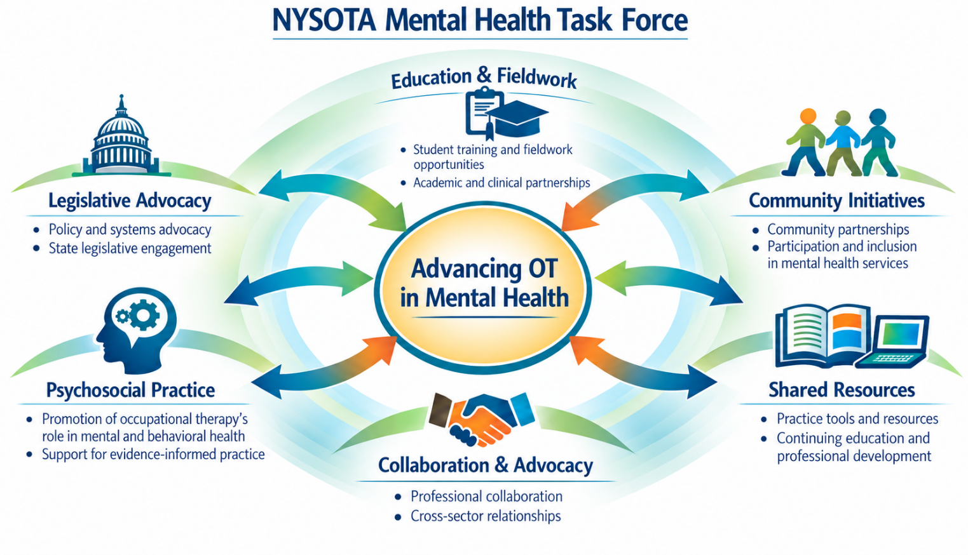
Note. Figure generated using an artificial intelligence image-generation tool based on author-developed content and reviewed by the authors. The six domains represent interconnected areas of historical engagement and advocacy; arrows indicate reciprocal relationships rather than chronological or causal relationships.

Action 1: Build a Shared Purpose and an Enduring Structure
The founding members, including Joan Feder, Diane Tewfik, Sheri Wadler, Anne Hiller Scott, Suzanne White, Mary V. Donohue, and Cheryl King, recognized that isolated efforts would not be sufficient. They organized around a shared purpose: keeping occupational therapy visible, valued, and integrated within mental health services. The task force created a place where practitioners, educators, students, and advocates could exchange information, identify emerging threats and opportunities, and coordinate responses (NYSOTA, 2025).
A state association or regional group can begin with a small, clearly defined structure. Identify a coordinator, establish a regular communication channel, and develop two or three priorities grounded in local needs. Membership should include practitioners from different settings and career stages, educators, students, and people with policy or community connections. Continuity is strengthened when responsibilities, contacts, advocacy history, and active projects are documented rather than held by one person.
A useful first step is to ask three questions: Where is occupational therapy absent from mental health policy or service planning? What evidence demonstrates occupational therapy’s distinct contribution? Who must understand that contribution for change to occur? The answers provide a focused agenda and prevent the group from becoming only a discussion forum.

Action 2: Listen Before Proposing Solutions
Effective advocacy begins with understanding the priorities and constraints of decision-makers. In New York, advocates Christine Linkie, Jeff Tomlinson, and David Merlo listened to leaders from the New York State Office of Mental Health (OMH) as the agency redesigned Personalized Recovery Oriented Services (PROS). They then connected those expressed needs to occupational therapy’s expertise in routines, roles, functional cognition, environmental supports, and community participation (Merlo et al., 2025).
This relationship-centered approach contributed to recognition of occupational therapists as Licensed Practitioners of the Healing Arts in New York State and supported inclusion of occupational therapy in OMH-funded programs such as PROS (Merlo et al., 2025). The broader lesson is transferable: begin with the system’s problem, use the language of the decision-maker, and show how occupational therapy addresses outcomes that matter to that system. National efforts, including advocacy related to mental health parity, can reinforce local work, but state-specific opportunities and barriers still require tailored strategies (Haertl, 2016; Wilburn et al., 2021).
Before approaching an agency or legislator, practitioners can prepare a concise description of the problem, the population affected, occupational therapy’s distinct contribution, supporting evidence, and one specific requested action. Follow-up should document commitments and maintain the relationship even when policy change is not immediate.

Action 3: Connect Advocacy to Workforce and Practice Capacity
Recognition in policy has limited impact unless occupational therapy practitioners have opportunities to enter, sustain, and demonstrate their value in mental health practice. Connecting advocacy with recruitment, fieldwork education, professional development, and practice resources can strengthen workforce and service capacity. The New York City Behavioral Health Career Roadmap identifies a pathway from occupational therapy assistant to occupational therapist (New York City Mayor’s Office, 2025). Although relevant to workforce development, the roadmap alone does not establish the MHTF’s role in its creation. Likewise, specific MHTF contributions to state workforce or loan repayment initiatives should be attributed only when supported by documentation.
Community-based practice offers another illustration. Tewfik and Scott (2022) reported that Project Renewal employed more than 20 occupational therapists and hosted approximately 50 interns annually at the time of their account. These historical figures demonstrate potential employment and experiential-learning opportunities; they should not be interpreted as verified current staffing or placement levels. Groups seeking similar growth can identify mental health settings without occupational therapy services, engage employers and academic programs, and explore fieldwork placements or pilot services. Workforce data, placement capacity, service outcomes, and employer perspectives can then inform sustained advocacy.
Action 4: Make Occupational Therapy Visible Through Practice
The MHTF’s community initiatives have kept advocacy connected to occupation-centered practice. Partnerships with local chapters of the National Alliance on Mental Illness led to OTs Walk with NAMI, which promoted wellness, physical activity, and occupational engagement in day treatment programs and psychiatric clubhouses. Publicly accessible resources from the SUNY Downstate Occupational Therapy Program describe walking protocols and group wellness approaches that clinician can adapt (SUNY Downstate Health Sciences University, n.d.). The task force also supported practice tools that address participation, routines, executive functioning, and psychosocial engagement. Occupation-centered resources relevant to this work include Let’s Get Organized (White, 2007), the Social Profile (Donohue, 2022), and the Dream Home Assessment (Raphael-Greenfield & Grajo, 2021). These resources illustrate approaches to addressing participation, routines, executive functioning, and psychosocial engagement in occupational therapy practice.
Visibility grows when practitioners describe not only what they do, but also why the intervention is occupational therapy and what changed for the people served. Groups can support this by collecting short case examples, sharing outcome measures, hosting practice discussions, and creating resources that translate evidence into usable clinical strategies.

Action 5: Develop the Next Generation of Advocates
Mentorship has been central to the MHTF’s longevity. Students, early-career practitioners, mid-career leaders, and founders have worked together through educational programming, fieldwork partnerships, listserv discussions, presentations, and professional collaboration. This intergenerational structure preserves institutional memory while allowing new members to contribute contemporary perspectives and skills (NYSOTA, 2025).
The MHTF School-Based Team has described orientation materials, resource guides, and presentations addressing mental health considerations in fieldwork education (NYSOTA, 2025). Coopersmith et al. (2025) presented Fieldwork with Feeling as an educational example. These examples illustrate ways to support fieldwork educators and emerging practitioners without assuming changes in the prevalence of student needs. Other groups can support succession by pairing emerging and experienced members, assigning students meaningful project roles, rotating leadership responsibilities, and archiving initiatives and outcomes. Mentorship should provide opportunities to contribute as well as observe.

Action 6: Measure Progress and Communicate Results
Advocacy groups strengthen their credibility when they document both activities and outcomes. Activity measures may include meetings with agencies, educational events, resources developed, students mentored, or new organizational partners. Outcome measures show whether the work changed policy, access, workforce capacity, practice, or public understanding. Examples include occupational therapy being added to regulatory language, new reimbursable roles, additional fieldwork sites, increased practitioner positions, use of an occupation-centered resource, or improved stakeholder knowledge.
Measures should match the maturity of the initiative. A new coalition may track participation, stakeholder feedback, and commitments obtained. A more established initiative may monitor policy milestones, workforce trends, referral patterns, service reach, or occupational participation outcomes. Qualitative evidence, such as accounts from clients, practitioners, employers, and students, can clarify how and why a change matters, but it should complement rather than replace available quantitative information.
Communication should be planned from the beginning. A brief annual summary can record priorities, actions, outcomes, unfinished work, and next steps. Sharing results through association channels, professional meetings, educational programs, and practice publications helps others adapt successful strategies and prevents knowledge from being lost during leadership transitions.
The six actions derived from the MHTF's historical experiences are presented in Figure 2 as an interconnected framework for advancing occupational therapy in mental health. Together, these actions emphasize sustained organizational engagement, responsive advocacy, workforce development, practice visibility, mentorship, and accountability.
Figure 2
Collaborative Framework for Advancing Occupational Therapy in Mental Health
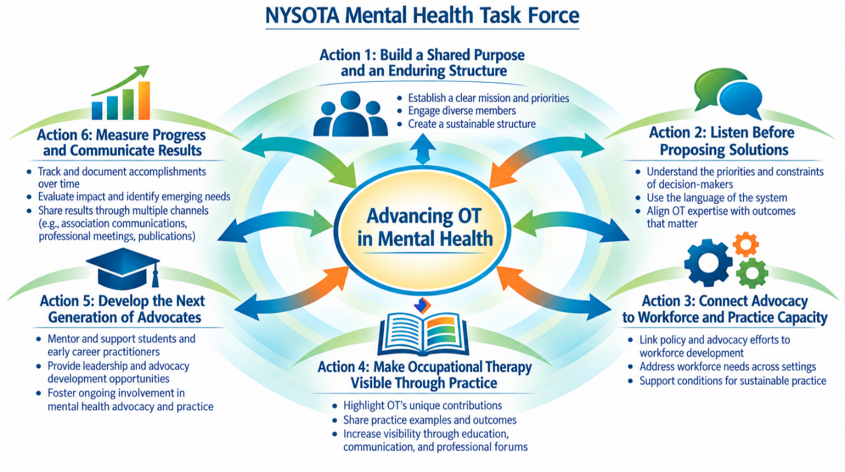
Note. Figure generated with an artificial intelligence image-generation tool based on author-developed content and reviewed by the authors for accuracy and alignment with the manuscript.

A Practical Starting Framework
The six actions above describe strategic priorities. The following five-step cycle translates them into a practical sequence for implementation:
1. Identify a specific gap in policy, workforce, education, or service delivery.
2. Convene practitioners, educators, students, community partners, and people with relevant lived or systems experience.
3. Gather evidence and examples that connect occupational therapy to the priorities of the intended audience.
4. Request a concrete change, such as revised policy language, inclusion in a funding mechanism, a pilot service, or a fieldwork partnership.
5. Document outcomes, share resources, mentor new contributors, and refine the next priority.
This cycle can be scaled to a local practice setting, a state association, or a national coalition. The essential elements are a clear purpose, credible evidence, relationships with decision-makers and community partners, and a plan for continuity.
Limitations and future directions: This account draws on selected records and contributor perspectives from one state; the completeness of the historical record and the attribution of outcomes to any single organization are limited. Differences in regulation, financing, workforce capacity, geography, and association partnerships may affect transferability. Future evaluation could track changes in occupational therapy employment, service access, and policy implementation following specific advocacy milestones, and compare coalition approaches across states.

Conclusion
The NYSOTA MHTF's history from 1995 through 2025 illustrates how sustained, collaborative advocacy may contribute to policy recognition, workforce development, professional education, and the advancement of occupational therapy in mental health practice. Its most transferable lesson is that professional visibility must be built through repeated action: listening to system needs, articulating occupational therapy’s distinct value, developing practice capacity, documenting outcomes, and preparing new leaders. State associations and local groups do not need to reproduce the New York model exactly. They can begin with one clearly defined gap, one coalition of committed partners, and one actionable request. and then build from the results.

For questions about collaboration, advocacy initiatives, or NYSOTA MHTF activities, contact mentalhealthtaskforce@gmail.com

AI and Language Model Disclosure
AI tools were used for organizational and editorial refinement and to generate Figure 1 and 2 from author-developed content. The authors reviewed and verified the manuscript and figure and remain responsible for their accuracy and integrity.

References
Coopersmith, A., Martinez-Almonte, M., & Scott, A. (2025, May 14). Fieldwork with feeling:
Empowering OT fieldwork students to support positive mental health in schools [PowerPoint slides]. MOTEC Virtual Meeting. NYSOTA Mental Health MHTF School-Based Team.
Donohue, M. V. (2022). Social Profile: Assessment of social participation in children,
adolescents, and adults. AOTA Press.
Haertl, K. (2016). Reviving OT’s roots in mental health: Minnesota’s grassroots mental health
action group. OT Practice, 21(21), 13–16.
Merlo, D., Nowatniak, S., & Linkie, C. (2025, May 14). OTs recognized as licensed
practitioners of the healing arts in NYS PROS programs. New York State Occupational
Therapy Association. https://www.nysota.org/news/news.asp?id=700760
New York City Mayor’s Office. (2025, January 2). Behavioral Health Career Roadmap.
https://mentalhealth.cityofnewyork.us/workforce-career-roadmap
New York State Occupational Therapy Association. (2025). Mental Health MHTF: Celebrating
30 years of advocacy and impact [Presentation].
Ozelie, R., Delehoy, M., Jones, S., Sykstus, E., & Weil, V. (2019). Accommodation use by
individuals with disabilities in occupational therapy fieldwork. Journal of Occupational Therapy Education, 3(4). Article 7. https://doi.org/10.26681/jote.2019.030407
Raphael-Greenfield, E., & Grajo, L. C. (2021). The clinical utility of the Dream Home
Assessment: An occupational therapy evaluation of executive functioning. Occupational Therapy in Mental Health, 37(4), 370–385. https://doi.org/10.1080/0164212X.2021.1944103
SUNY Downstate Health Sciences University. (n.d.). OTs walk with NAMI. School of Health
Professions, Occupational Therapy Program. https://www.downstate.edu/education-training/school-of-health-professions/programs/occupational-therapy/community-engagement/nami.html
Tewfik, D. B., & Scott, A. H. (2022). Highlighting OT’s role in mental health: An innovative
fieldwork program for community-based mental health. OT Practice, 27(9), 18–21.
White, S. (2007). Let’s get organized: An intervention for persons with co-occurring disorders.
Psychiatric Services, 58(5), 713. https://doi.org/10.1176/ps.2007.58.5.713
Wilburn, V. G., Hoss, A., Pudeler, M., Beukema, E., Rothenbuhler, C., & Stoll, H. B. (2021).
Health Policy Perspectives—Receiving recognition: A case for occupational therapy practitioners as mental and behavioral health providers. American Journal of Occupational Therapy, 75(5), 7505090010. https://doi.org/10.5014/ajot.2021.044727

